Problem Statement
Problem Statement: AI-Powered Restaurant Recommendation System (Zomato Use Case)
You are tasked with building an AI-powered restaurant recommendation service inspired by Zomato. The system should intelligently suggest restaurants based on user preferences by combining structured data with a Large Language Model (LLM).
Objective
Design and implement an application that:
- Takes user preferences (such as location, budget, cuisine, and ratings)
- Uses a real-world dataset of restaurants
- Leverages an LLM to generate personalized, human-like recommendations
- Displays clear and useful results to the user
System Workflow
- Data Ingestion
  - Load and preprocess the Zomato dataset from Hugging Face (https://huggingface.co/datasets/ManikaSaini/zomato-restaurant-recommendation )
  - Extract relevant fields such as restaurant name, location, cuisine, cost, rating, etc.
- User Input
  - Collect user preferences:
    - Location (e.g., Delhi, Bangalore)
    - Budget (low, medium, high)
    - Cuisine (e.g., Italian, Chinese)
    - Minimum rating
    - Any additional preferences (e.g., family-friendly, quick service)
- Integration Layer
  - Filter and prepare relevant restaurant data based on user input
  - Pass structured results into an LLM prompt
  - Design a prompt that helps the LLM reason and rank options
- Recommendation Engine
  - Use the LLM to:
    - Rank restaurants
    - Provide explanations (why each recommendation fits)
    - Optionally summarize choices
- Output Display
  - Present top recommendations in a user-friendly format:
    - Restaurant Name
    - Cuisine
    - Rating
    - Estimated Cost
    - AI-generated explanation

Diagram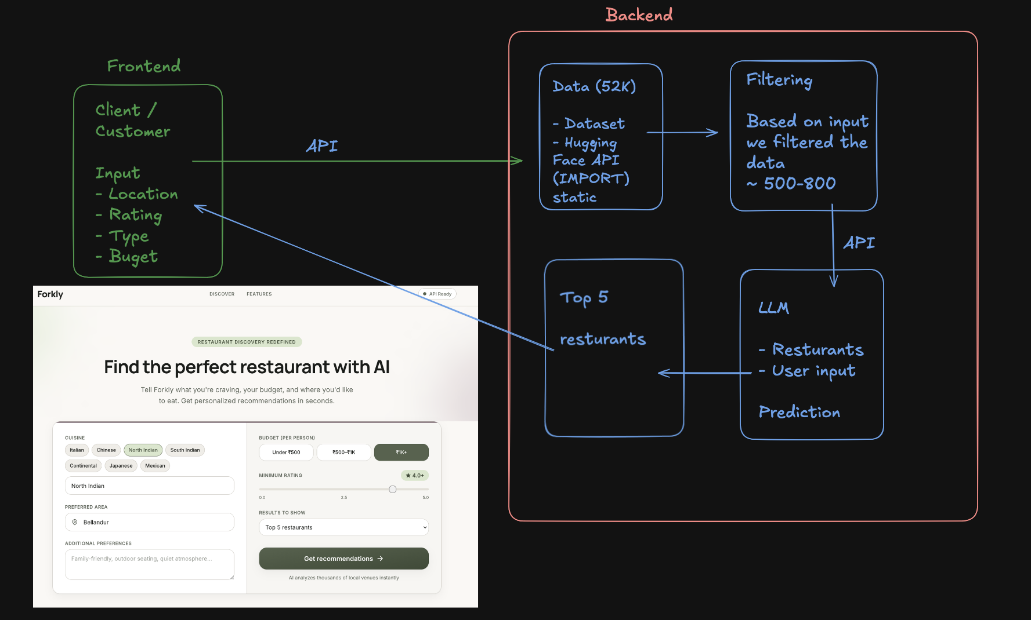

AI Tools
- https://cursor.com/download
- https://antigravity.google/product/antigravity-ide (ANTIGRAVITY IDE) (PRO – JIO SIM) https://www.jio.com/google-gemini-offer/
- https://qoder.com/

FOR GENERATING CONTEXT FILES in antigravity → Use Pro model or claude opus

API Key
- https://groq.com/ → Free API key → Create API key
- https://aistudio.google.com/api-keys

Frontend / Backend
- Backend
  - Python, FastAPI
  - Nodejs, expressjs
  - Java, Spring Boot, C#, .NET

- Frontend
- Streamlit → Basic UI
- React, Vite, Next.js → Good quality UI (VERCEL)

Designing
- https://stitch.withgoogle.com
- https://recent.design/?ref=godly
- Figma, Canva etc → MCP (LATER after 2 weeks)

Steps
CONTEXT SETUP
- Docs folder
  - problemStatement.txt → Basic problem statement of the project
  - context.md → stores the necessary context of the project
  - architecture.md → detailed description of the project building
  - implementation-plan.md → phase-wise implementation plan
  - edge-case.md → corner scenario (LIVING DOCUMENT)
  - deployment-plan.md
IMPLEMENTATION
MANUAL TESTING
DEPLOYMENT

PROMPT
- Generate a context.md which stores the entire context of @docs/problemStatement.txt
- Generate a detailed architecture.md using @docs/context.md
- LLM used in this project will be Groq, update it in the @docs/architecture.md
- Generate a phase-wise implementation-plan.md using the @docs/architecture.md and @docs/context.md
- Generate an edge-case.md for this project which contains all the corner scenarios
- Implement phase0 as per the @docs/implementation-plan.md
- Implement phase1 as per the @docs/implementation-plan.md
- Implement phase2 as per the @docs/implementation-plan.md
- Implement phase3 as per the @docs/implementation-plan.md

— GET the API key from https://groq.com/ and update in it .env
Ask cursor to create .env.example or .env

- In data location is Bangalore, ideally we should have indiranagar, bellandur etc in place or location as they will be the required input later on (YOU)
- Location - Bellandur
Rating - 4.2
Budget - 1500
Predict top5 restaurants for these input with the help of LLM, API key is present in .env
- In @docs/implementation-plan.md we want to have 2 different phases for backend and frontend. We want a good quality frontend for this application.
- Implement phase4 backend part 1 as per the @docs/implementation-plan.md
- Using the @docs/context.md @docs/architecture.md
generate a prompt for google stitch for designing the frontend
PROMPT is below
- Using @stitch_zomato_ai_recommendations folder design and basic images of the website are present use them and
Images of food are currently not required so we can skip them
In locations there should be a dropdown rather than text input.
implement frontend as per the @docs/implementation-plan.md
MANUAL TESTING
- run the entire project
Open the project URL → http://localhost:3000 (URL can be different for you)
- stop the project
- For MG road and other places we notices duplicate entries are coming in the final result, ideally unique restaurants we should return
PUSH the code to github
- CHECK .gitignore file is present
- PUSH the code to github - https://github.com/saksham20189575/milestone-zomato.git
DEPLOYMENT
- Create a deployment-plan.md for this project and I want to deploy backend on railway and frontend on vercel.
- Do the necessary code changes for deploying basis of @docs/deployment-plan.md
- Push the code changes to github
- DEPLOY – BACKEND
3-4 bugs can come up
- Railway deployment is failing → <ERROR>
- DEPLOY – FRONTEND
- Backend
  - Railway → https://railway.com/ (GITHUB)
  - Streamlit → https://share.streamlit.io/ (GITHUB)
  - Render
- Frontend
  - Vercel → https://vercel.com/

PROMPT for stitch
Design a desktop-first web application home screen for an AI-powered restaurant recommendation product inspired by Zomato, optimized for laptop screens (1280px–1440px width), where users set dining preferences in a left panel and see ranked restaurant suggestions with AI-written explanations in a right panel.
Include a full-width top navigation bar with a food/dining logo on the left, product title "Zomato AI Recommendations", and tagline "Find your perfect restaurant" aligned to the right.
Include a centered main layout with max-width 1200px split into two columns: left column (40%) titled "Your preferences" containing a compact form with searchable location dropdown, budget dropdown with helper labels (Low under ₹500, Medium ₹501–1500, High above ₹1500), optional cuisine dropdown defaulting to "Any cuisine", minimum rating slider from 0.0 to 5.0 with live value label, multiline text area for additional preferences with placeholder "e.g. family-friendly, quick service", and a full-width primary button "Get Recommendations".
Include a right column (60%) titled "Recommendations" showing applied filter chips (location, budget, cuisine, min rating), an AI summary banner with subtle sparkle icon and quote-style text, and a vertical list of up to 5 recommendation cards each with rank badge (#1 gold, #2 silver, #3 bronze), bold restaurant name, cuisine pill tags, star rating with numeric score, cost formatted as "₹1,200 for two", and a 2–3 line AI explanation, with subtle hover lift on each card.
Include supporting UI states within the same screen: empty state in the right column before search ("Your top picks will appear here"), loading state with skeleton cards and message "AI is ranking restaurants for you…", empty results state with "No restaurants matched your filters" and suggestions to broaden search, amber warning banner when filters were relaxed, red inline validation errors below form fields with tappable location suggestion chips, and a dismissible error alert bar below the header for server failures.
Include a simple centered footer with muted copyright text.
Style: Zomato-inspired warm red primary (#E23744), white page background, light gray (#F8F8F8) panel backgrounds, dark text (#1C1C1C), Inter or modern sans-serif typography, subtle card shadows, generous 24–32px spacing, professional food-discovery mood, polished consumer product not a developer prototype.
Optimize for desktop web and laptop browsing at 1280px+, mouse hover interactions on cards and buttons, clear left-form right-results split, no mobile stacking, WCAG AA color contrast, keyboard-navigable form controls.

Basic INTRO steps
– Any md file (PREVIEW)
→ Ctrl + Shift + V (Windows)
→ Mac → Cmd + Shift + V

Mentioning FILE → use @

Extension for Diagrams → Mermaid
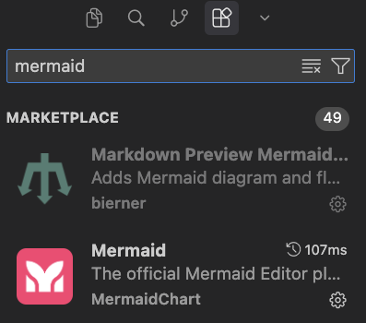
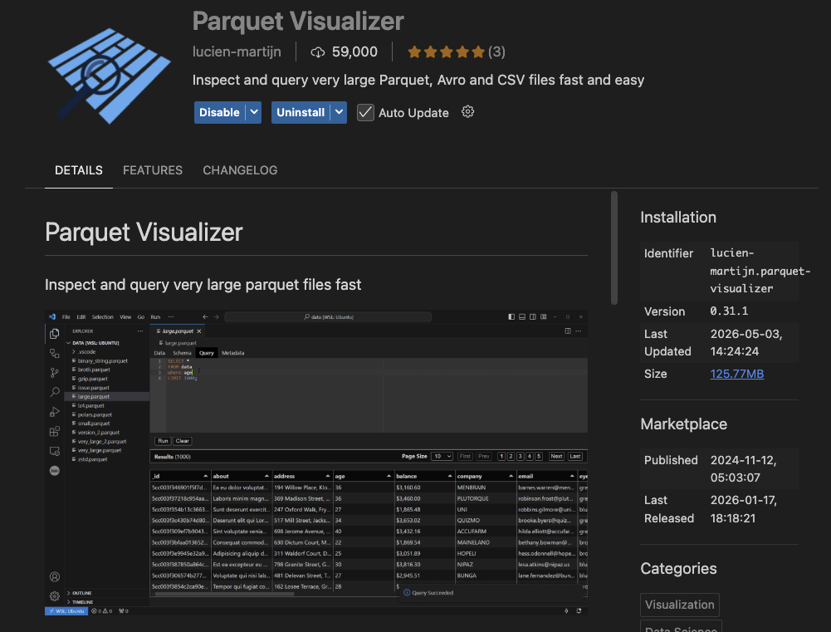

Architecture

Architecture: AI-Powered Restaurant Recommendation System
This document describes the technical architecture for the Zomato-inspired restaurant recommendation service defined in context.md. The system combines structured restaurant data from Hugging Face with Groq LLM inference to produce personalized, explainable recommendations.

1. Architecture Goals
Goal | Description
Separation of concerns | Data loading, filtering, LLM reasoning, and presentation are isolated modules with clear interfaces.
Deterministic pre-filtering | Hard constraints (location, budget, rating) are applied before the LLM to reduce token cost and hallucination risk.
Explainability | Every recommendation includes an LLM-generated rationale tied to user preferences.
Extensibility | Swap UI frameworks or data sources without rewriting core logic; LLM access is isolated behind a Groq adapter.
Testability | Pure functions for filtering/ranking prep; mockable LLM adapter for unit tests.

3. Component Architecture
3.1 Data Ingestion Layer
Responsibility: Load, normalize, and cache the Zomato dataset once at startup (or on first request).
Component | Role
DatasetLoader | Fetches ManikaSaini/zomato-restaurant-recommendation via datasets (Hugging Face).
DataPreprocessor | Maps raw columns to a canonical schema, handles nulls, normalizes text fields.
RestaurantRepository | In-memory query interface over the preprocessed dataset.
Canonical restaurant schema:
Restaurant = {
"id": str, # stable identifier (index or dataset id)
"name": str,
"location": str, # city / locality
"cuisines": list[str], # e.g. ["Italian", "Continental"]
"cost_for_two": int, # numeric cost indicator
"rating": float, # e.g. 4.2
"votes": int, # optional: popularity signal
"rest_type": str, # optional: casual dining, cafe, etc.
}

Preprocessing steps:
- Download dataset split (typically train).
- Select and rename relevant columns to the canonical schema.
- Parse cuisine strings into lists (e.g. "Italian, Chinese" → ["Italian", "Chinese"]).
- Coerce rating and cost to numeric types; drop or impute invalid rows.
- Normalize location strings (trim, title-case, alias map for city names).
- Derive budget_tier from cost_for_two using configurable thresholds:
Tier | Typical cost_for_two range (INR)
low | ≤ 500
medium | 501 – 1500
high | > 1500
Thresholds should be tuned after inspecting the actual dataset distribution.
Caching strategy: Load once into a pandas DataFrame or list of Restaurant objects. Persist a local parquet/CSV snapshot to avoid repeated Hugging Face downloads during development.

3.2 User Input Layer
Responsibility: Collect, validate, and normalize user preferences.
Input model:
UserPreferences = {
"location": str, # required
"budget": str, # "low" | "medium" | "high"
"cuisine": str | None, # optional primary cuisine
"min_rating": float, # e.g. 3.5
"additional": str | None, # free-text: "family-friendly, quick service"
}

Component | Role
PreferenceForm | UI form or CLI prompt collecting fields.
PreferenceValidator | Enforces required fields, enum values, rating bounds.
PreferenceNormalizer | Lowercases cuisine, maps city aliases, trims free text.
Validation rules:
- location — non-empty; must match at least one value in the dataset (or suggest closest matches).
- budget — one of low, medium, high.
- min_rating — float in [0.0, 5.0].
- cuisine — optional; fuzzy match against known cuisine vocabulary extracted from dataset.
- additional — optional free text passed through to the LLM for soft matching.

3.3 Integration Layer
Responsibility: Apply hard filters, rank candidates heuristically, and assemble the LLM prompt.
This layer sits between structured data and the LLM. It ensures the model only reasons over a bounded, relevant candidate set.
3.3.1 Restaurant Filter
Applies deterministic filters in sequence:
all restaurants
→ filter by location (exact or case-insensitive match)
→ filter by budget tier
→ filter by min_rating
→ filter by cuisine (if provided; match if cuisine in restaurant.cuisines)
→ sort by rating desc, then votes desc
→ take top N candidates (default N = 15–20)

Component | Role
RestaurantFilter | Executes filter pipeline; returns list[Restaurant].
CandidateSelector | Caps result count and applies tie-breaking.
If zero candidates remain, relax constraints in order: cuisine → budget → min_rating, and surface a warning to the user.
3.3.2 Prompt Builder
Constructs a structured prompt containing:
- System instructions — role, output format (JSON), ranking criteria.
- User preferences — serialized UserPreferences.
- Candidate restaurants — compact JSON array of filtered restaurants.
- Task — rank top K (e.g. 5), explain each pick, optionally summarize.
Design principles:
- Require JSON output from the LLM for reliable parsing.
- Include restaurant id in candidates so explanations map back to structured data.
- Instruct the model to only recommend from the provided list (no fabrication).
- Pass additional preferences as soft signals the LLM may use in ranking/explanation.
Example prompt structure (conceptual):
[System]
You are a restaurant recommendation assistant for Indian cities.
Rank restaurants from the CANDIDATES list only. Return valid JSON.

[User Preferences]
{ location, budget, cuisine, min_rating, additional }

[Candidates]
[ { id, name, location, cuisines, cost_for_two, rating }, ... ]

[Task]
Return top 5 restaurants as JSON:
{
"summary": "...",
"recommendations": [
{
"id": "...",
"rank": 1,
"explanation": "..."
}
]
}

3.4 Recommendation Engine (LLM Layer)
Responsibility: Invoke the LLM, handle retries, parse and validate the response, merge with structured data.
Component | Role
LLMClient | Thin adapter over the Groq API via the official groq Python SDK.
RecommendationService | Orchestrates prompt → LLM → parse → enrich.
ResponseParser | Parses JSON; validates schema; handles malformed output.
RecommendationEnricher | Joins LLM ranks/explanations with full restaurant records.
Output model:
Recommendation = {
"rank": int,
"name": str,
"cuisine": str, # joined cuisine string for display
"rating": float,
"estimated_cost": int, # cost_for_two
"explanation": str, # LLM-generated
}

RecommendationResponse = {
"summary": str | None,
"recommendations": list[Recommendation],
"metadata": {
"candidates_considered": int,
"filters_applied": dict,
"model": str,
}
}

Reliability patterns:
Pattern | Purpose
Structured output / JSON mode | Reduce parse failures.
Retry with temperature reduction | Recover from invalid JSON.
Fallback ranking | If LLM fails, return heuristic top-K by rating with a generic explanation.
Idempotency | Same preferences + same dataset snapshot → reproducible candidate set.
LLM is not used for:
- Loading data
- Hard filtering by location/budget/rating
- Inventing restaurants not in the candidate list
Groq Integration
Groq is the sole LLM provider for this project. The LLMClient wraps Groq's chat completions API and is configured via environment variables.
Setting | Default | Notes
SDK | groq | Official Python client (pip install groq).
API key | GROQ_API_KEY | Required; set in .env, never committed.
Model | llama-3.3-70b-versatile | Strong reasoning for ranking and explanations.
Fallback model | llama-3.1-8b-instant | Optional faster/cheaper alternative for dev.
Temperature | 0.3 | Low enough for consistent JSON; retry with 0.1 on parse failure.
Client usage (conceptual):
from groq import Groq

client = Groq(api_key=settings.GROQ_API_KEY)

response = client.chat.completions.create(
model=settings.GROQ_MODEL,
messages=[
{"role": "system", "content": system_prompt},
{"role": "user", "content": user_prompt},
],
temperature=settings.GROQ_TEMPERATURE,
response_format={"type": "json_object"}, # when supported by model
)

Groq-specific considerations:
- Groq offers very low latency inference — suitable for interactive UI feedback.
- Enforce JSON output in the prompt; use response_format={"type": "json_object"} where the selected model supports it.
- Handle Groq rate limits (429) with exponential backoff before falling back to heuristic ranking.
- Log model ID and latency per request; Groq responses include token usage in response.usage.

3.5 Output Display Layer
Responsibility: Render recommendations in a clear, scannable format.
Component | Role
RecommendationPresenter | Formats RecommendationResponse for UI or CLI.
ResultsView | Cards/table showing name, cuisine, rating, cost, explanation.
SummaryBanner | Optional LLM summary at the top.
Display requirements (from context):
Each result card/row must show:
- Restaurant Name
- Cuisine
- Rating
- Estimated Cost
- AI-generated explanation
UX considerations:
- Show applied filters (location, budget, etc.) above results.
- Display "no results" state with suggestions to broaden filters.
- Show loading state while dataset loads / LLM responds.
- Rank badge (1, 2, 3…) for quick scanning.

4. Request Flow (Sequence Diagram)
Recommendation ServiceGroq ClientPrompt BuilderRestaurant FilterRestaurant RepositoryPreference ValidatorAPI ControllerPresentation LayerRecommendation ServiceGroq ClientPrompt BuilderRestaurant FilterRestaurant RepositoryPreference ValidatorAPI ControllerPresentation LayerUserEnter preferencesPOST /recommendvalidate(preferences)UserPreferencesget_all() / queryrestaurants[]filter(restaurants, preferences)candidates[]build(preferences, candidates)promptrecommend(prompt, candidates)complete(prompt)JSON responseparse & enrichRecommendationResponseJSONRender ranked cardsUser

5. Proposed Module Structure
Recommended layout for a Python implementation:
zomato-milestone1/
├── docs/
│ ├── context.md
│ ├── architecture.md
│ └── problemStatement.txt
├── src/
│ ├── __init__.py
│ ├── main.py # entry point (CLI or app bootstrap)
│ ├── config.py # env vars, budget thresholds, top-K
│ ├── models/
│ │ ├── restaurant.py # Restaurant dataclass
│ │ ├── preferences.py # UserPreferences dataclass
│ │ └── recommendation.py # Recommendation, RecommendationResponse
│ ├── data/
│ │ ├── loader.py # Hugging Face dataset loader
│ │ ├── preprocessor.py # normalization & schema mapping
│ │ └── repository.py # in-memory query interface
│ ├── services/
│ │ ├── filter.py # RestaurantFilter
│ │ ├── prompt_builder.py # PromptBuilder
│ │ ├── llm_client.py # Groq API adapter
│ │ └── recommendation.py # RecommendationService orchestrator
│ ├── api/
│ │ ├── routes.py # FastAPI routes (optional)
│ │ └── schemas.py # request/response Pydantic models
│ └── ui/
│ ├── cli.py # terminal interface
│ └── streamlit_app.py # or Gradio web UI (optional)
├── tests/
│ ├── test_filter.py
│ ├── test_preprocessor.py
│ └── test_recommendation.py
├── data/ # cached parquet/csv (gitignored)
├── .env.example # GROQ_API_KEY and model config
├── requirements.txt
└── README.md

6. Technology Stack (Recommended)
Layer | Technology | Rationale
Language | Python 3.11+ | Strong ecosystem for data + LLM integration.
Dataset | datasets (Hugging Face) | Direct access to the specified dataset.
Data processing | pandas | Filtering, normalization, caching.
LLM | Groq (llama-3.3-70b-versatile) | Fast, low-latency inference for ranking + explanation tasks.
LLM SDK | groq | Official Groq Python client for chat completions.
API (optional) | FastAPI | Lightweight async REST for frontend decoupling.
UI (optional) | Streamlit or Gradio | Rapid prototyping of preference form + results.
Config | pydantic-settings + .env | Typed config and secret management.
Testing | pytest | Unit tests for filter, parser, preprocessor.

7. API Design (Optional REST Layer)
If exposing a backend API:
POST /api/v1/recommend
Request:
{
"location": "Bangalore",
"budget": "medium",
"cuisine": "Italian",
"min_rating": 4.0,
"additional": "family-friendly, outdoor seating"
}

Response:
{
"summary": "Based on your preference for Italian cuisine in Bangalore with a medium budget...",
"recommendations": [
{
"rank": 1,
"name": "Example Ristorante",
"cuisine": "Italian, Continental",
"rating": 4.5,
"estimated_cost": 1200,
"explanation": "Highly rated Italian spot within your budget, known for family-friendly ambiance."
}
],
"metadata": {
"candidates_considered": 18,
"filters_applied": {
"location": "Bangalore",
"budget": "medium",
"min_rating": 4.0,
"cuisine": "Italian"
},
"model": "llama-3.3-70b-versatile"
}
}

GET /api/v1/health
Returns service status and whether the dataset is loaded.
GET /api/v1/locations
Returns distinct locations from the dataset (populates UI dropdowns).
GET /api/v1/cuisines
Returns distinct cuisines extracted from the dataset.

8. Data Flow Summary
Hugging Face Dataset
│
▼
[Load & Preprocess] ──► RestaurantRepository (cached)
│
User Preferences ──► [Validate] ──► [Filter candidates]
│
▼
[Build LLM Prompt]
│
▼
[LLM Rank + Explain]
│
▼
[Parse & Enrich]
│
▼
RecommendationResponse ──► UI

9. Cross-Cutting Concerns
9.1 Configuration
Centralize in config.py:
- HF_DATASET_NAME
- BUDGET_THRESHOLDS
- MAX_CANDIDATES_FOR_LLM
- TOP_K_RECOMMENDATIONS
- GROQ_MODEL (default: llama-3.3-70b-versatile)
- GROQ_API_KEY
- GROQ_TEMPERATURE
- DATA_CACHE_PATH
9.2 Error Handling
Scenario | Behavior
Dataset download fails | Retry with backoff; show clear error in UI.
No restaurants match filters | Relax constraints or prompt user to adjust input.
LLM returns invalid JSON | Retry once; fallback to heuristic ranking.
LLM timeout / Groq 429 rate limit | Retry with backoff; then return heuristic top-K with note that AI explanation is unavailable.
Unknown location | Suggest valid locations from dataset.
9.3 Logging & Observability
- Log filter counts (input size → candidate size).
- Log LLM latency and token usage.
- Do not log full prompts containing API keys.
- Optional: trace ID per recommendation request.
9.4 Security
- Store API keys in environment variables, never in source control.
- Validate and sanitize all user inputs.
- Rate-limit API endpoints if deployed publicly.

10. Deployment Topology
Development (local):
Developer Machine
├── Python app (Streamlit / FastAPI + CLI)
├── Cached dataset in ./data/
└── Groq API (cloud)

Minimal production:
User
Streamlit / Static Frontend
FastAPI Backend
Dataset Cache
Groq API
- Pre-load dataset at container startup.
- Single-stateless API instance is sufficient for milestone scope.
- Scale horizontally later by sharing a read-only dataset snapshot.

11. Testing Strategy
Test type | Scope | Example
Unit | RestaurantFilter | Location + budget + rating filters return expected subset.
Unit | Preprocessor | Cuisine string parsing, numeric coercion.
Unit | ResponseParser | Valid/invalid LLM JSON handling.
Integration | RecommendationService | Mock LLM returns fixed JSON; verify enriched output.
Snapshot | PromptBuilder | Prompt contains all candidates and preference fields.
Use a frozen subset of the dataset (10–20 rows) in test fixtures for deterministic tests.

12. Implementation Phases
Phase | Deliverable
Phase 1 — Data | Load Hugging Face dataset, preprocess, cache, expose repository.
Phase 2 — Filter | Implement preference validation and deterministic filtering.
Phase 3 — LLM | Prompt builder, LLM client, response parser, enricher.
Phase 4 — UI | CLI or Streamlit form + results display.
Phase 5 — Hardening | Error handling, fallback ranking, tests, README.

13. Architecture Decisions
Decision | Choice | Alternatives considered
LLM provider | Groq (llama-3.3-70b-versatile) | OpenAI, Anthropic, local models
Pre-filter before LLM | Yes — hard filters in code | Let LLM filter entire dataset (expensive, unreliable)
LLM output format | Structured JSON | Free-form text (harder to parse)
Data storage | In-memory DataFrame | Database (unnecessary for read-only milestone dataset)
Ranking split | Heuristic shortlist + LLM final rank | Pure LLM or pure heuristic
UI approach | Streamlit for speed | React SPA (more effort for milestone 1)

14. Related Documents
- context.md — product requirements and workflow
- problemStatement.txt — original problem statement

Different ways we can develop a project

DEPLOYMENT PLAN
This document describes how to deploy the Zomato AI Restaurant Recommendation System with:
Component | Platform | Stack
Backend API | Railway | Python 3.11+, FastAPI, Uvicorn
Frontend UI | Vercel | Next.js 16, React 19
Deploy the backend first, then the frontend. The frontend needs the Railway public URL to call the API, and the backend needs the Vercel URL in CORS_ORIGINS.

Architecture (Production)
HTTPS fetch
NEXT_PUBLIC_API_URL
Browser
Vercel
Next.js frontend
Railway
FastAPI backend
Groq API
Hugging Face
dataset download
Request flow
- User opens the Vercel-hosted Next.js app.
- The browser calls the Railway API directly (frontend/lib/api.ts uses NEXT_PUBLIC_API_URL).
- On startup, Railway downloads (or re-downloads) the Zomato dataset from Hugging Face and caches it locally.
- Recommendation requests go through the filter pipeline and Groq LLM.

Prerequisites
Before deploying, gather:
Item | Where to get it
GitHub repo connected to Railway and Vercel | Push this project to GitHub
Groq API key (required) | Groq Console
Railway account | railway.app
Vercel account | vercel.com
No Hugging Face token is required for the public dataset ManikaSaini/zomato-restaurant-recommendation.

Part 1 — Backend on Railway
1.1 Create the Railway service
- Log in to Railway and click New Project.
- Choose Deploy from GitHub repo and select this repository.
- Railway auto-detects Python via requirements.txt at the repo root.
Important: Do not set the root directory to frontend. The backend lives at the repository root (src/, requirements.txt).
1.2 Configure the start command
Railway injects a dynamic PORT. Uvicorn must bind to 0.0.0.0 and that port.
In the service Settings → Deploy → Start Command, set:
uvicorn src.api.app:app --host 0.0.0.0 --port $PORT

Alternatively, add a Procfile at the repo root (Railway reads it automatically):
web: uvicorn src.api.app:app --host 0.0.0.0 --port $PORT

Do not use python src/main.py in production — that entry point hard-codes port 8000 and enables --reload.
1.3 Set environment variables
In Railway Variables, add:
Variable | Required | Example / notes
GROQ_API_KEY | Yes | Your Groq secret key
GROQ_MODEL | No | llama-3.3-70b-versatile (default)
GROQ_TEMPERATURE | No | 0.3
HF_DATASET_NAME | No | ManikaSaini/zomato-restaurant-recommendation
DATA_CACHE_PATH | No | data/restaurants.parquet
MAX_CANDIDATES_FOR_LLM | No | 20
TOP_K_RECOMMENDATIONS | No | 5
BUDGET_LOW_MAX | No | 500
BUDGET_MEDIUM_MAX | No | 1500
CORS_ORIGINS | Yes (after Vercel) | See CORS setup below
Reference: .env.example at the repo root and src/config.py.
1.4 Generate a public domain
- Open the Railway service → Settings → Networking.
- Click Generate Domain (e.g. https://zomato-api-production.up.railway.app).
- Save this URL — you will use it as NEXT_PUBLIC_API_URL on Vercel.
1.5 First deploy behavior
On the first boot (and after every redeploy), the backend:
- Attempts to load data/restaurants.parquet from the local filesystem.
- If missing, downloads the dataset from Hugging Face (can take 30–90+ seconds).
- Preprocesses, deduplicates, and caches the parquet file.
Railway uses an ephemeral filesystem — the cache is lost on redeploy. The app handles this by re-downloading from Hugging Face. Expect slower cold starts after redeploys.
Optional hardening (not required for MVP):
- Attach a Railway Volume mounted at /app/data and set DATA_CACHE_PATH=data/restaurants.parquet so the cache survives redeploys.
- Increase health-check timeout in Railway if deploys fail while the dataset is still downloading.
1.6 Verify the backend
Replace YOUR_RAILWAY_URL with your generated domain:
curl https://YOUR_RAILWAY_URL/api/v1/health
curl https://YOUR_RAILWAY_URL/api/v1/locations
curl https://YOUR_RAILWAY_URL/api/v1/cuisines
curl -X POST https://YOUR_RAILWAY_URL/api/v1/recommend \
-H "Content-Type: application/json" \
-d '{"location":"Indiranagar","budget":"medium","cuisine":"Italian","min_rating":4.0}'

Expected health response when healthy:
{
"status": "ok",
"dataset_loaded": true,
"restaurant_count": <number>
}

OpenAPI docs: https://YOUR_RAILWAY_URL/docs

Part 2 — Frontend on Vercel
2.1 Import the project
- Log in to Vercel and click Add New → Project.
- Import the same GitHub repository.
- Configure the project:
Setting | Value
Framework Preset | Next.js (auto-detected)
Root Directory | frontend
Build Command | npm run build (default)
Output Directory | .next (default)
Install Command | npm install (default)
2.2 Set environment variables
In Vercel Project → Settings → Environment Variables:
Variable | Environments | Value
NEXT_PUBLIC_API_URL | Production, Preview, Development | https://YOUR_RAILWAY_URL (no trailing slash)
Use Railway's public domain from Settings → Networking → Generate Domain (e.g. https://your-app.up.railway.app). Do not use private internal hostnames such as https://your-app.railway.internal — browsers and Vercel cannot resolve them.
NEXT_PUBLIC_* variables are embedded at build time. After changing this value, trigger a redeploy on Vercel.
The frontend reads this in:
- frontend/lib/api.ts — browser fetch calls to the API
- frontend/next.config.ts — optional rewrites for /api/* paths
2.3 Deploy
Click Deploy. Vercel builds Next.js from the frontend/ directory and assigns a URL such as https://your-project.vercel.app.
2.4 Verify the frontend
- Open the Vercel production URL.
- Confirm location and cuisine dropdowns populate (calls GET /api/v1/locations and /cuisines).
- Submit a recommendation form and confirm results render with explanations.
- Check the browser Network tab — API requests should go to your Railway domain, not localhost:8000.

CORS setup
The FastAPI app allows origins listed in CORS_ORIGINS (src/config.py → src/api/app.py).
After Vercel is live, update Railway:
CORS_ORIGINS=https://your-project.vercel.app,https://www.your-domain.com

Use comma-separated URLs with no spaces (or spaces are trimmed automatically).
Preview deployments: Vercel preview URLs look like https://your-project-git-branch-user.vercel.app. FastAPI CORS does not support wildcards — either:
- Add each preview URL manually to CORS_ORIGINS, or
- Use a single production frontend URL for demos, or
- Extend the backend later with dynamic origin validation for *.vercel.app.
Redeploy or restart the Railway service after updating CORS_ORIGINS.

Deployment order checklist
Use this sequence to avoid CORS and missing-URL issues:
- [ ] 1. Create Railway project from GitHub (repo root).
- [ ] 2. Set Railway start command: uvicorn src.api.app:app --host 0.0.0.0 --port $PORT.
- [ ] 3. Set GROQ_API_KEY (and optional tuning vars) on Railway.
- [ ] 4. Generate Railway public domain.
- [ ] 5. Wait for deploy; verify /api/v1/health returns "status": "ok".
- [ ] 6. Create Vercel project with Root Directory = frontend.
- [ ] 7. Set NEXT_PUBLIC_API_URL to the Railway URL on Vercel.
- [ ] 8. Deploy Vercel; note the production URL.
- [ ] 9. Set CORS_ORIGINS on Railway to include the Vercel URL.
- [ ] 10. Redeploy Railway (or restart) and re-test the full UI flow.

Environment variable reference
Backend (Railway)
Variable | Default | Description
GROQ_API_KEY | — | Groq API key (required for recommendations)
GROQ_MODEL | llama-3.3-70b-versatile | Groq model
GROQ_TEMPERATURE | 0.3 | Sampling temperature
HF_DATASET_NAME | ManikaSaini/zomato-restaurant-recommendation | Hugging Face dataset
DATA_CACHE_PATH | data/restaurants.parquet | Local parquet cache path
MAX_CANDIDATES_FOR_LLM | 20 | Max restaurants sent to LLM
TOP_K_RECOMMENDATIONS | 5 | Recommendations returned
BUDGET_LOW_MAX | 500 | Low budget upper bound (INR)
BUDGET_MEDIUM_MAX | 1500 | Medium budget upper bound (INR)
CORS_ORIGINS | localhost defaults | Comma-separated allowed frontend origins
Frontend (Vercel)
Variable | Default | Description
NEXT_PUBLIC_API_URL | http://localhost:8000 | Railway backend base URL

Troubleshooting
Symptom | Likely cause | Fix
Health returns "status": "degraded" | Dataset failed to download at startup | Check Railway logs; confirm outbound network access; retry deploy
Browser: "Unable to reach server" | Wrong NEXT_PUBLIC_API_URL or backend down | Verify Railway URL; redeploy Vercel after env change
CORS error in browser console | Vercel URL not in CORS_ORIGINS | Add exact origin to Railway; restart service
Recommendations fail with 503 | Missing GROQ_API_KEY | Set key on Railway
Slow first request after deploy | Hugging Face download + preprocessing | Normal on ephemeral disk; consider Railway Volume
API calls still hit localhost:8000 | Stale Vercel build | Confirm NEXT_PUBLIC_API_URL is set for Production and redeploy
Location dropdown stuck on "Loading…" or empty | NEXT_PUBLIC_API_URL set to Railway internal URL (e.g. *.railway.internal) | Use the public domain from Railway → Settings → Networking → Generate Domain (e.g. https://your-app.up.railway.app), redeploy Vercel
Vercel /api/v1/* returns 502 DNS_HOSTNAME_NOT_FOUND | Same as above — rewrite target is an unreachable internal hostname | Replace internal URL with Railway public domain and redeploy
422 on recommend | Invalid location/cuisine | Use values from /api/v1/locations and /api/v1/cuisines
Logs
- Railway: service → Deployments → view build/runtime logs.
- Vercel: project → Deployments → Functions / Build Logs.

Optional enhancements
Enhancement | Platform | Benefit
Custom domain | Vercel + Railway | Branded URLs; update CORS_ORIGINS and NEXT_PUBLIC_API_URL
Railway Volume for data/ | Railway | Faster restarts; no re-download on redeploy
GitHub Actions CI | GitHub | Run pytest before merge (see existing tests/)
Staging environment | Vercel Preview + second Railway service | Isolated preview API with matching CORS entry
Rate limiting / API key | Railway middleware | Protect public Groq-backed endpoint

Local vs production summary
Concern | Local dev | Production
Backend URL | http://localhost:8000 | https://*.up.railway.app
Frontend URL | http://localhost:3000 | https://*.vercel.app
API env (frontend) | frontend/.env.local → NEXT_PUBLIC_API_URL | Vercel env vars
API secrets | .env → GROQ_API_KEY | Railway env vars
CORS | Default localhost origins | Must include Vercel URL
Dataset cache | Persists in data/ locally | Ephemeral unless Volume attached

Related documentation
- README.md — setup and API reference
- frontend/README.md — frontend development
- architecture.md — system design
- implementation-plan.md — build phases

Backend database is empty on Railway
Even when calling the correct backend directly, recommendations always come back empty:
curl -X POST https://restaurant-recommendation-production-721e.up.railway.app/api/recommend \
-H "Content-Type: application/json" \
-d '{"location":"Indiranagar","budget":"medium","cuisine":"Italian","min_rating":4.0}'
# → []
The API only exposes two routes (from openapi.json):
Endpoint | Purpose
GET / | Welcome message
POST /api/recommend | Filter DB + Groq ranking
There is no /api/v1/locations or /health — that’s expected for this repo.
Root cause: data/restaurants.db never reaches Railway
In SayokChoudhury/Restaurant-Recommendation, the seed database lives at:
data/restaurants.db (~1.9 MB, committed in repo)
But backend/database.py expects it at ../data/restaurants.db relative to the backend folder. Railway is almost certainly deployed with Root Directory = backend, so only the backend folder is copied — data/restaurants.db is not in the container.
On startup the code then does:
- Look for bundled DB → not found
- Print: WARNING: No bundled database found. Starting with empty database.
- Create empty SQLite at /tmp/data/restaurants.db
- Every /api/recommend query returns []
Data ingestion (python data_ingestion.py) is manual and not run on deploy.

